39) Aim: To Design DFA using simulator to accept the string the end with abc over set {a,b,c) W= abbaababc.

Diagram:

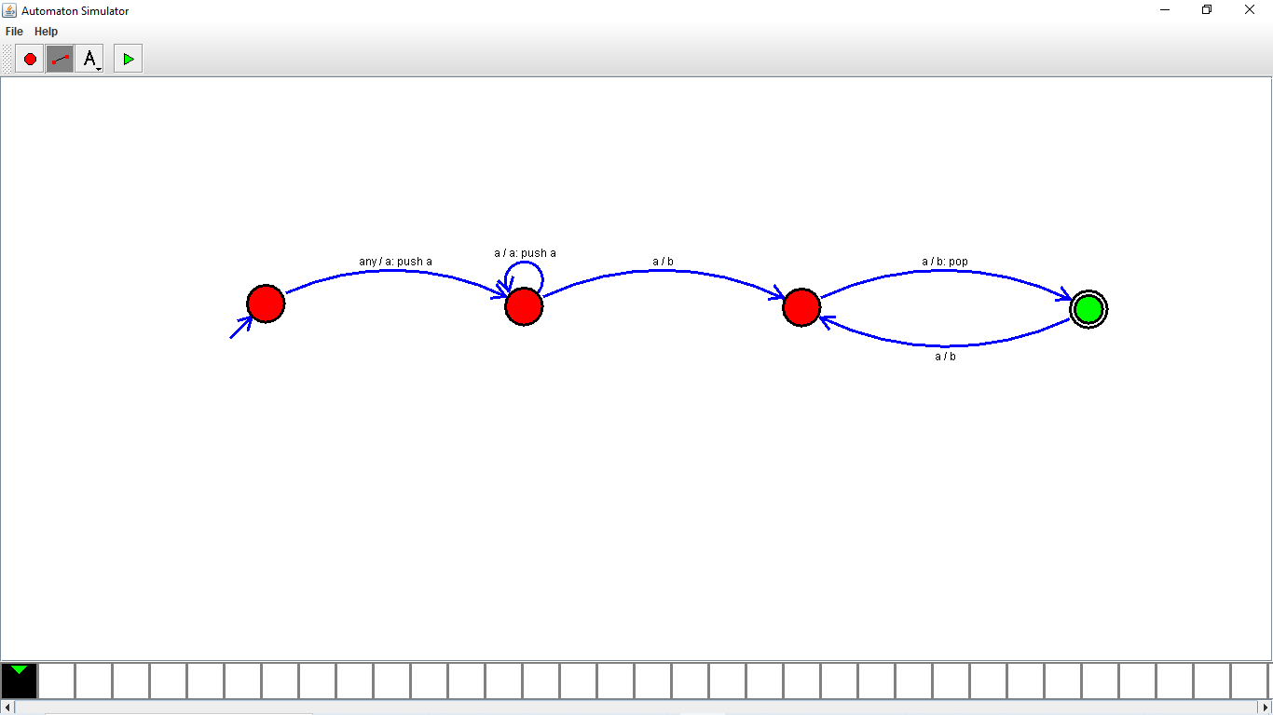

Result:

Successfully executed DFA using simulator to accept the string the end with abc over set {a,b,c) W= abbaababc.